PRACTICAL ADVICES

Bed linen etc.: Please be reminded that linen and towels are not included, bring your own!

Electricity: If switched off: open in a box in the hall, with a main switch

Extra key: to be found in a little pot, either on the shelf in the kitchen or in the cupboard. To be left on the same spot when you leave for home

Kitchen: the kitchen is all new. There is a special fluid to clean the surface of the cooking plate. The combined dish- and oven can not be used at the same time. Make sure to turn off the functions when not in use.

Sunblind: Always roll in the sunblind when you leave the apartment! If wet, let it dry first

Tennis: tennis has to be booked at A.S.L.I.C, see below.

Swim: There are some cards (in the cover), those are private. It costs a little to get in (10 times entry card for 25 Euro or 12.50 Euro for the kids). Time: 10:00-20:00.

If any problem: contact A.S.L.I.C. – it is situated behind square Martinique in a small house close to a long pole (they have also an extra key) or directly to us +46-739 640 122 (mobile), +46-8-965276 (home). If repairs are needed you can contact Jeff van de Weijer who sits on square Martinique (renting agency Euro-Select vacances), ), phone: +33 (468) 86 15 29 .

To call: Buy a special telephone card for calls call abroad (newspaper kiosk at the square)

Shops: - square Martinique
- village (super U), exit 10 towards Perpignan
- Carrefour (superstore), on the way towards Perpignan ca.13 km, exit Centre Comercialle
- Auchuan (superstore) at Route de Espagne, drive though whole Perpignan (straight ahead all time)

Bathe: You can swim at the playa in the lagoon. As for the see, Lydia beach is closest, drive left and then under the main road. You can even go by foot, ca 15 minutes, or take a free minitrain from the square. You can even go to Lecaute plage, direction towards Narbonne, ca 10 km.

Parking in Perpignan: NOTE! Cars are towed away when wrongly parked.

Travel back to Barcelona: (count ca. 4 hours) NOTE! Drive towards Perpignan. Highway starts before Perpignan (ca 8 km before (north of) Perpignan, 13-14 km from Cap Coudalere). Blue marks. Note! Next entrance is south of Perpignan, so do not miss the entrance.

Extra tip for other guests: leave tips about interesting places to see, good restaurants etc.

Laundry: Laundry rooms exist on site. One is situated on the back of square Martinique (behind boulangerie) and one pays with Euro coins. Another is situated on the other side of the pool. There, tokens can be purchased at Pierre Vacances on the square (eventually even tokens to dry). NOTE! Rather expensive! This laundry room is closed Saturdays. NOTE! Large token – laundry, small - dry.

Before leaving the apartment

- Cleaning is included, but please do some preliminary cleaning
- If asked by us, electricity can be shut in the hall, at the entrance
- Defreeze the refrigerator (in good time, so it is dry). Let the door stay open
- Do not forget to throw out all open food and garbage
- Lock the balcony door+ Venetian blind + window in the bedroom, draw the curtains. Pile outdoor chairs and fold up the outdoor table. Put them inside!!!
- Clean the grill place if you have used it.
- Roll in the sunblind! If wet, let it dry first
- Leave the extra key in the apartment
- If asked by us, turn the water of. The water can be turned off with a tap which can be found in a cupboard on street level under the house, close to post boxes. Check the apartment number very carefully!

DRIVING DIRECTIONS - CAR

From north: highway all the way from Danish –German border (ca. 1700 km, 18-20 driving hours). Leave the highway ca. 25 km south of Narbonne-exit 40 “Port Leucate” – drive towards Port Leucate (do not turn there) and then Port Barcares. Exit at exit nr. 13 – direction Cap Coudalere – and follow the marks all the way to Cap Coudalere. When you approach the site you can see a neon sign ”Cap Coudalere” in front of you. Make sure to turn left BEFORE the tennis courts on Boulevard Guadeloupe (ca 100 m. before the neon sign), see the detailed map below.

From south: Drive the highway north passing Perpignan and exit at exit 41 “Perpignan north”, drive east D83 direction Port Barcares, towards the see. Exit at exit 12 and follow the marks all the way to Cap Coudalere (distance from highway exit ca. 12-14 km). When you approach the site you can see a neon sign ”Cap Coudalere” in front of you. Make sure to turn left BEFORE the tennis courts on Boulevard Guadeloupe (ca 100 m. before the neon sign), see the detailed map below.

Adress: Apartment 207, (house Parc Dominica), Av. Dominica, Cap Coudelere

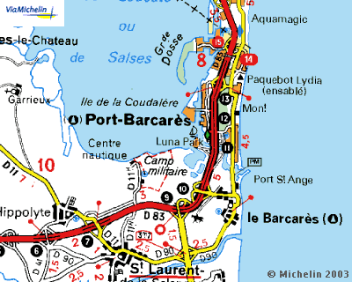
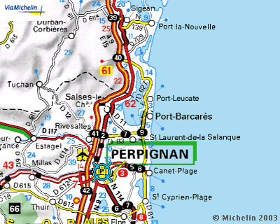
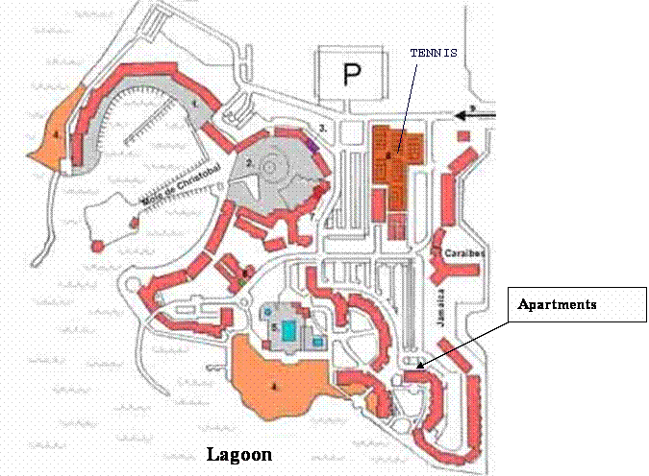
Le Barcares.
Place Martinique
Pools
Cap Coudalere
Phone numbers

Girona airport information: +34-972-186 708
Ryanair (Spain) +34-972 1866 06 or 807-220 032
Ryanair (Girona) 807-220 220
Ryanair (World) +35 31 24 97 791
Travel information.: 17
Emergency 112

